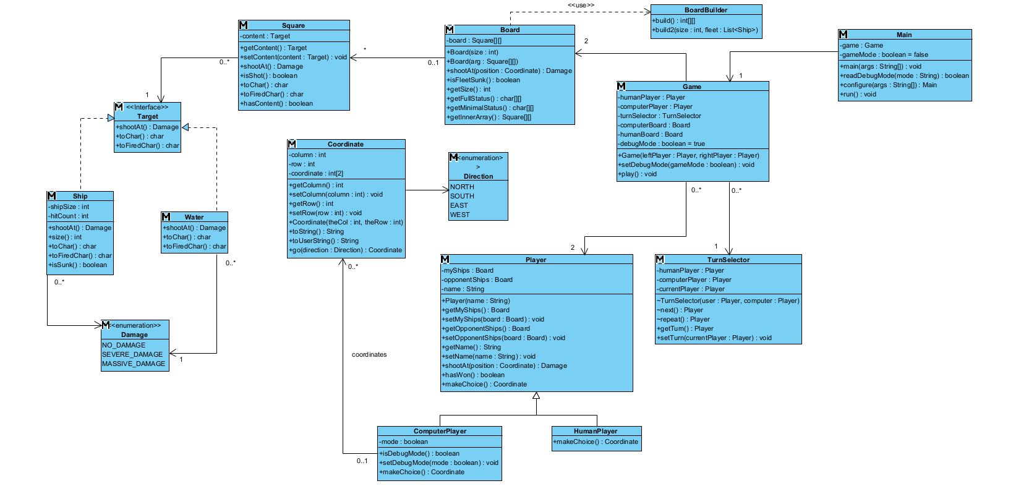
EXERCISE 1 – CLASS DIAGRAM

EXERCISE 2 – SEQUENCE DIAGRAM
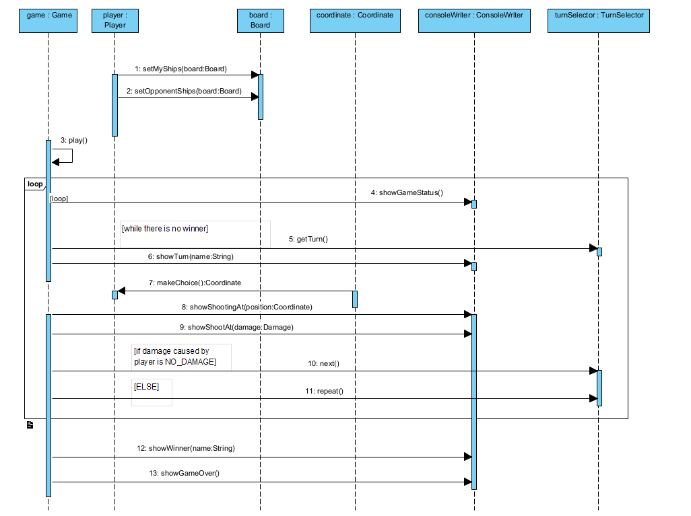

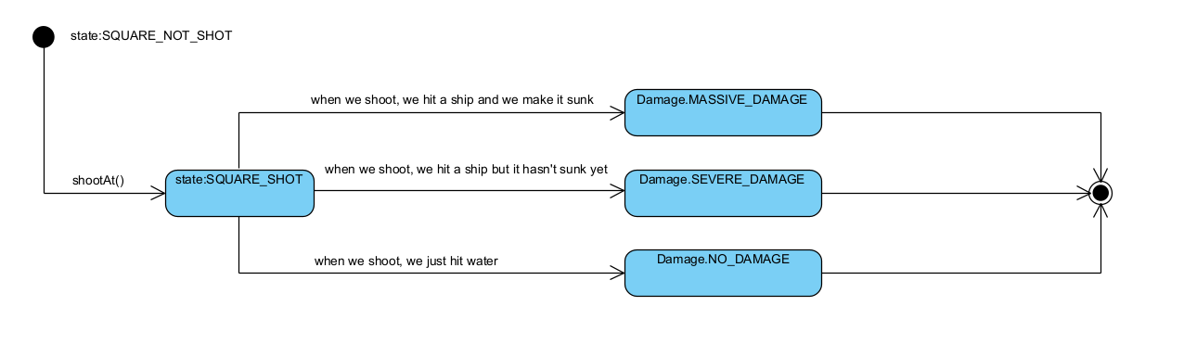
EXERCISE 3 – STATE DIAGRAM

EXERCISE 4 – ACTIVITY DIAGRAM
